

International School

**Capstone Project 2**

CMU-SE 451

**Meeting With Mentor Document**

**Craft Village Pollution Monitor System**

**Submitted by**

**Ca, Van Cong Le**

**Huy, Bui Duc**

**Phuc, Hua Hoang**

**Trung, Nguyen Thanh**

**Nhan, Huynh Ba**

**Approved by**

**Ph.D. Nguyen Thanh Binh**

**Proposal Review Panel Representative:**

Name Signature Date

**Capstone Project 2 - Mentor:**

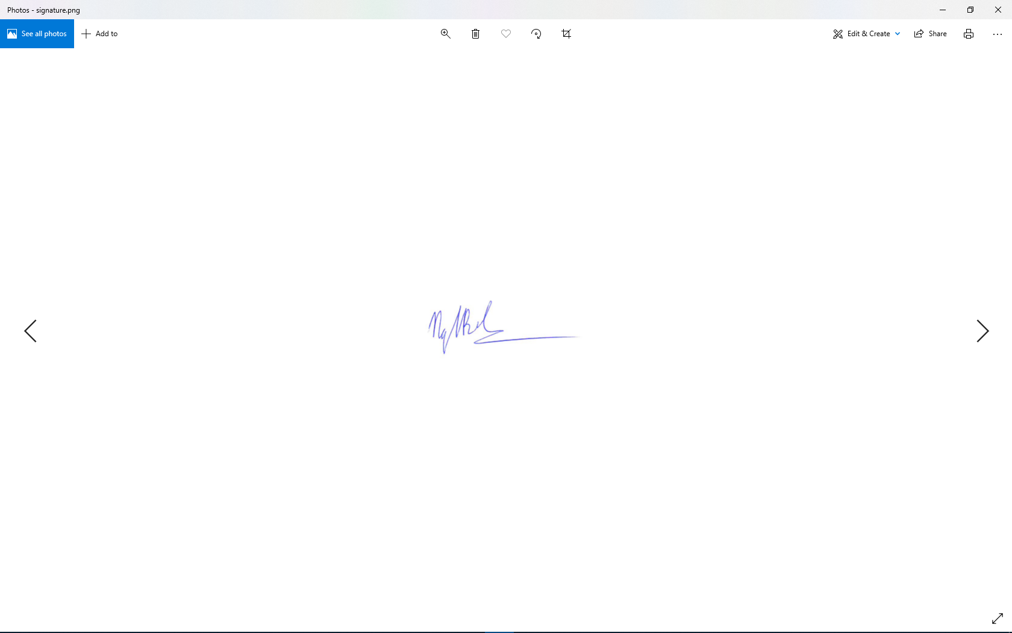

Name Signature Date

|  |  |  |  |  |
| --- | --- | --- | --- | --- |
| Meeting Information | | | | |
| Product | Craft Village Pollution Monitor System | | | |
| Subject | First meeting with mentor | | | |
| Location | Online on skype | | | |
| Date and Time | *Date* | *Start Time* | | *End Time* |
|  | 03/03/2023 | 20:00 | | 21:00 |
| Attendees | * Nguyen Thanh Binh * Van Cong Le Ca * Bui Duc Huy * Hua Hoang Phuc * Nguyen thanh Trung * Huynh Ba Nhan | | **Mentor Signature** | |
| Related documents | Proposal document | | | |
| Content | | | | |
| * Introducing new member * Demo of the functions implemented in capstone 1 * Get new requests for capstone 2 * Push mobile apps to the store and Backend, web application to online * Check the system when deploying online | | | | |
| Result Items | | | | |
| * Required documents: * Project Proposal * Project Plan * Architecture Document * Test Plan | | | | |

|  |  |  |  |  |
| --- | --- | --- | --- | --- |
| Meeting Information | | | | |
| Product | Craft Village Pollution Monitor System | | | |
| Subject | First meeting with mentor | | | |
| Location | Online on skype | | | |
| Date and Time | *Date* | *Start Time* | | *End Time* |
|  | 13/03/2023 | 20:00 | | 20:35 |
| Attendees | * Nguyen Thanh Binh * Van Cong Le Ca * Bui Duc Huy * Hua Hoang Phuc * Nguyen thanh Trung * Huynh Ba Nhan | | **Mentor Signature** | |
| Related documents | All documents | | | |
| Content | | | | |
| * Update the situation of the capstone 2 project: * Mobile apps pushed to Google Play Store * Backend and Web application pushed to AWS * AI up and running through AWS * Get more project requests: * Documentation that clearly describes AI and Location-based workflows. * Deploy system test on real device. Especially mobile applications need to run on real phones to check and report errors on different types of mobile phones. | | | | |
| Result Items | | | | |
| * Required documents: * Project Proposal * Project Plan * Architecture Document * Test Plan | | | | |

|  |  |  |  |  |
| --- | --- | --- | --- | --- |
| Meeting Information | | | | |
| Product | Craft Village Pollution Monitor System | | | |
| Subject | Technical review | | | |
| Location | Online on skype | | | |
| Date and Time | *Date* | *Start Time* | | *End Time* |
|  | 22/03/2023 | 20:00 | | 20:45 |
| Attendees | * Nguyen Thanh Binh * Van Cong Le Ca * Bui Duc Huy * Hua Hoang Phuc * Nguyen thanh Trung * Huynh Ba Nhan | | **Mentor Signature** | |
| Related documents | Architecture Document, Test Cases | | | |
| Content | | | | |
| * Update the situation of the capstone 2 project: * Mobile apps pushed to the Google Play Store are approved by Google and allow users to download. * Backends, web apps, and AI uploaded to AWS are made into services to avoid crashes and manual restarts. * Clarifying AI and location-based workflow. | | | | |
| Result Items | | | | |
| * Required documents: * Architecture Document * Test Cases | | | | |

|  |  |  |  |  |
| --- | --- | --- | --- | --- |
| Meeting Information | | | | |
| Product | Craft Village Pollution Monitor System | | | |
| Subject | Idea clarification and demo | | | |
| Location | Online on skype | | | |
| Date and Time | *Date* | *Start Time* | | *End Time* |
|  | 30/03/2023 | 20:00 | | 20:35 |
| Attendees | * Nguyen Thanh Binh * Van Cong Le Ca * Bui Duc Huy * Hua Hoang Phuc * Nguyen thanh Trung * Huynh Ba Nhan | | **Mentor Signature** | |
| Related documents | Architecture Document, Test Cases | | | |
| Content | | | | |
| * Demo function of production declaration. * Demo function report. * Design dashboard of local government (In process). * Clarification of AI and Location-based workflows. * Request capstone 2 project update: * AI and Location-Based Documentation. | | | | |
| Result Items | | | | |
| * Required documents: * Architecture Document * Test Cases | | | | |

|  |  |  |  |  |
| --- | --- | --- | --- | --- |
| Meeting Information | | | | |
| Product | Craft Village Pollution Monitor System | | | |
| Subject | Technical review and demo | | | |
| Location | Online on skype | | | |
| Date and Time | *Date* | *Start Time* | | *End Time* |
|  | 06/04/2023 | 23:00 | | 00:00 |
| Attendees | * Nguyen Thanh Binh * Van Cong Le Ca * Bui Duc Huy * Hua Hoang Phuc * Nguyen thanh Trung * Huynh Ba Nhan | | **Mentor Signature** | |
| Related documents | Architecture Document, Test Cases | | | |
| Content | | | | |
| * Update the situation of capstone 2 project: * Backend, web application and AI are uploaded to VPS rented in Vietnam to replace the previous AWS. * Fix mobile apps when running on real devices. * Demo of positioning functions on the product when running online. * Clarifying AI and location-based workflows. | | | | |
| Result Items | | | | |
| * Required documents: * Architecture Document * Test Cases | | | | |

|  |  |  |  |  |
| --- | --- | --- | --- | --- |
| Meeting Information | | | | |
| Product | Craft Village Pollution Monitor System | | | |
| Subject | Idea clarification and demo | | | |
| Location | Online on skype | | | |
| Date and Time | *Date* | *Start Time* | | *End Time* |
|  | 13/04/2023 | 20:30 | | 21:10 |
| Attendees | * Nguyen Thanh Binh * Van Cong Le Ca * Bui Duc Huy * Hua Hoang Phuc * Nguyen thanh Trung * Huynh Ba Nhan | | **Mentor Signature** | |
| Related documents | Architecture Document, Test Cases | | | |
| Content | | | | |
| * More demo about having 2-3 craft villages in one location. * The AI team will have a report as well as seek additional opinions to come up with a new AI that matches the requirements. * Clarifying AI and location-based workflows: * When making decisions, AI needs to synthesize information from craft villages and photos to be able to make the most accurate decisions. * Unify how to generate/Data to train AI. | | | | |
| Result Items | | | | |
| * Required documents: * Architecture Document * Test Cases | | | | |

|  |  |  |  |  |
| --- | --- | --- | --- | --- |
| Meeting Information | | | | |
| Product | Craft Village Pollution Monitor System | | | |
| Subject | Idea clarification and demo | | | |
| Location | Online on skype | | | |
| Date and Time | *Date* | *Start Time* | | *End Time* |
|  | 20/04/2023 | 20:30 | | 21:30 |
| Attendees | * Nguyen Thanh Binh * Van Cong Le Ca * Bui Duc Huy * Hua Hoang Phuc * Nguyen thanh Trung * Huynh Ba Nhan | | **Mentor Signature** | |
| Related documents | Architecture Document, Test Cases | | | |
| Content | | | | |
| * Team AI will have a report as well as ask for more opinions on creating data sets for train AI. * Clarification of AI and Location-based workflows. * Agree on how to get GPS tags for LSB. | | | | |
| Result Items | | | | |
| * Required documents: * Architecture Document * Test Cases | | | | |

|  |  |  |  |  |
| --- | --- | --- | --- | --- |
| Meeting Information | | | | |
| Product | Craft Village Pollution Monitor System | | | |
| Subject | Technical review and demo | | | |
| Location | Online on skype | | | |
| Date and Time | *Date* | *Start Time* | | *End Time* |
|  | 08/05/2023 | 20:00 | | 21:00 |
| Attendees | * Nguyen Thanh Binh * Van Cong Le Ca * Bui Duc Huy * Hua Hoang Phuc * Nguyen thanh Trung * Huynh Ba Nhan | | **Mentor Signature** | |
| Related documents | Architecture Document, Test Cases | | | |
| Content | | | | |
| * Team AI will report: * Train dataset * The questionnaire affects the type of pollution the craft village can cause * Random Forest algorithm application. * Application of Decision Tree algorithm. * Use standard Exif and metadata tags for LSB: * GPS GPSLatitude * GPS GPSLatitudeRef * GPS GPSLongitude * GPS GPSLongitudeRef * DateTime | | | | |
| Result Items | | | | |
| * Required documents: * Architecture Document * Test Cases | | | | |

|  |  |  |  |  |
| --- | --- | --- | --- | --- |
| Meeting Information | | | | |
| Product | Craft Village Pollution Monitor System | | | |
| Subject | Demo | | | |
| Location | Online on skype | | | |
| Date and Time | *Date* | *Start Time* | | *End Time* |
|  | 15/05/2023 | 20:00 | | 20:50 |
| Attendees | * Nguyen Thanh Binh * Van Cong Le Ca * Bui Duc Huy * Hua Hoang Phuc * Nguyen thanh Trung * Huynh Ba Nhan | | **Mentor Signature** | |
| Related documents | All Documents | | | |
| Content | | | | |
| * Team AI will report: * Train dataset * The questionnaire affects the type of pollution the craft village can cause * Random Forest algorithm application. * Application of Decision Tree algorithm. * Handling survey conflicts with pollution of craft villages. | | | | |
| Result Items | | | | |
| * Required documents: * All Documents | | | | |